Great Western PFHA is proud to host a Trail Horse Test and Clinic. All breeds welcome.
- Cost: $50 per day per horse/rider. Our appreciation to the Paso Fino Horse Association for their generous financial support of this event.
~ Includes morning clinic, lunch, afternoon test, Junior test fee, and stall for one night.
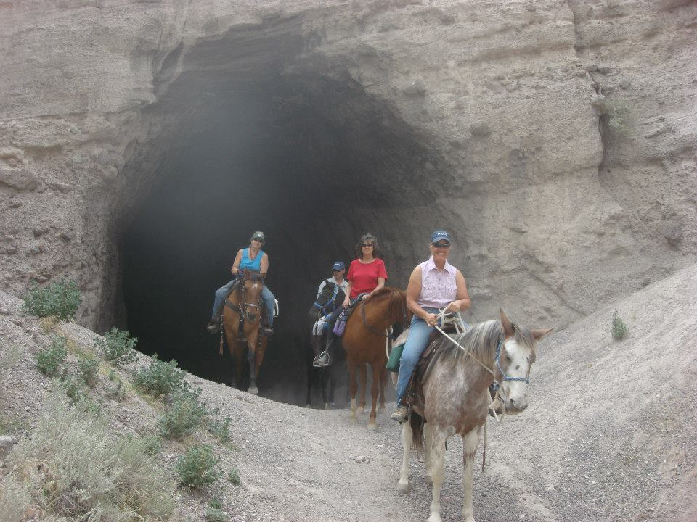
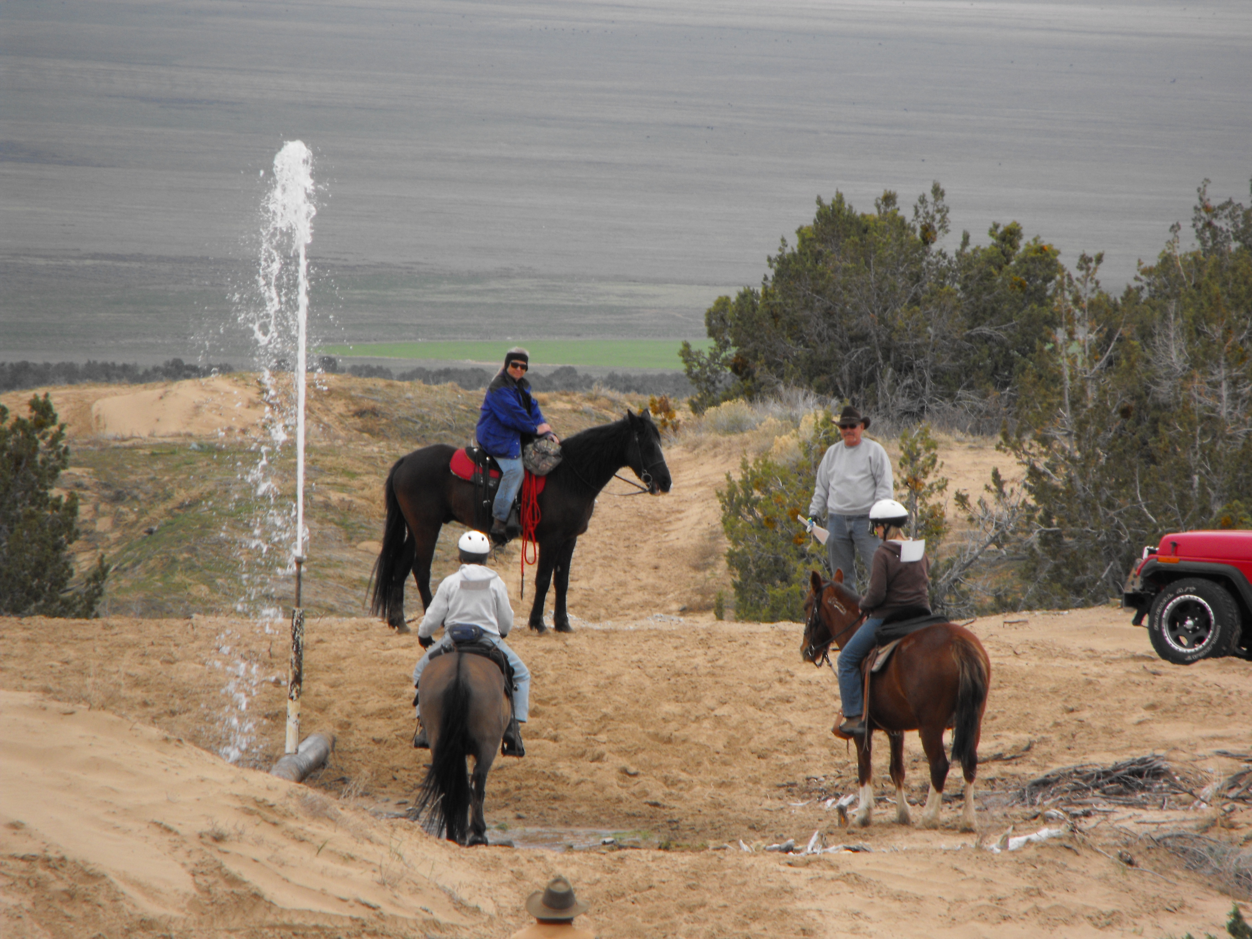
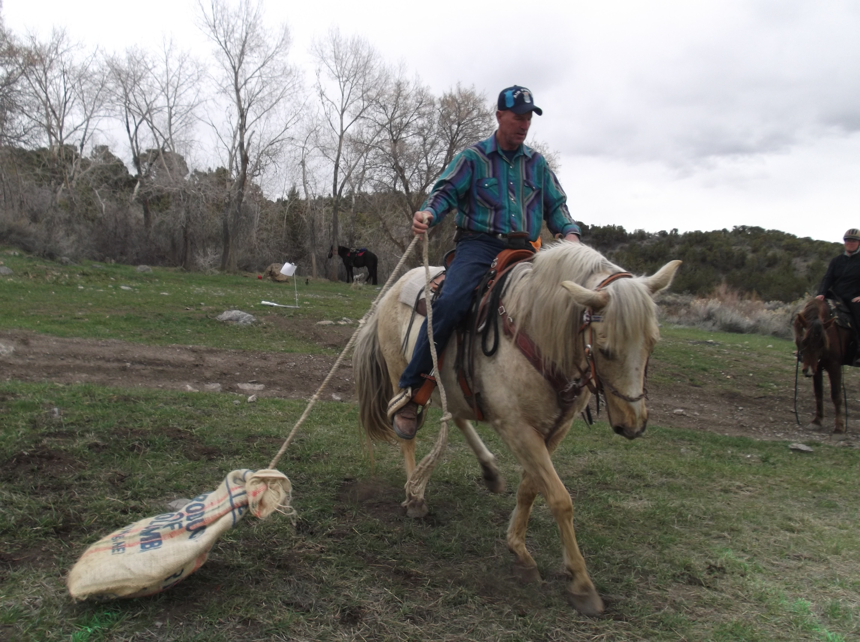
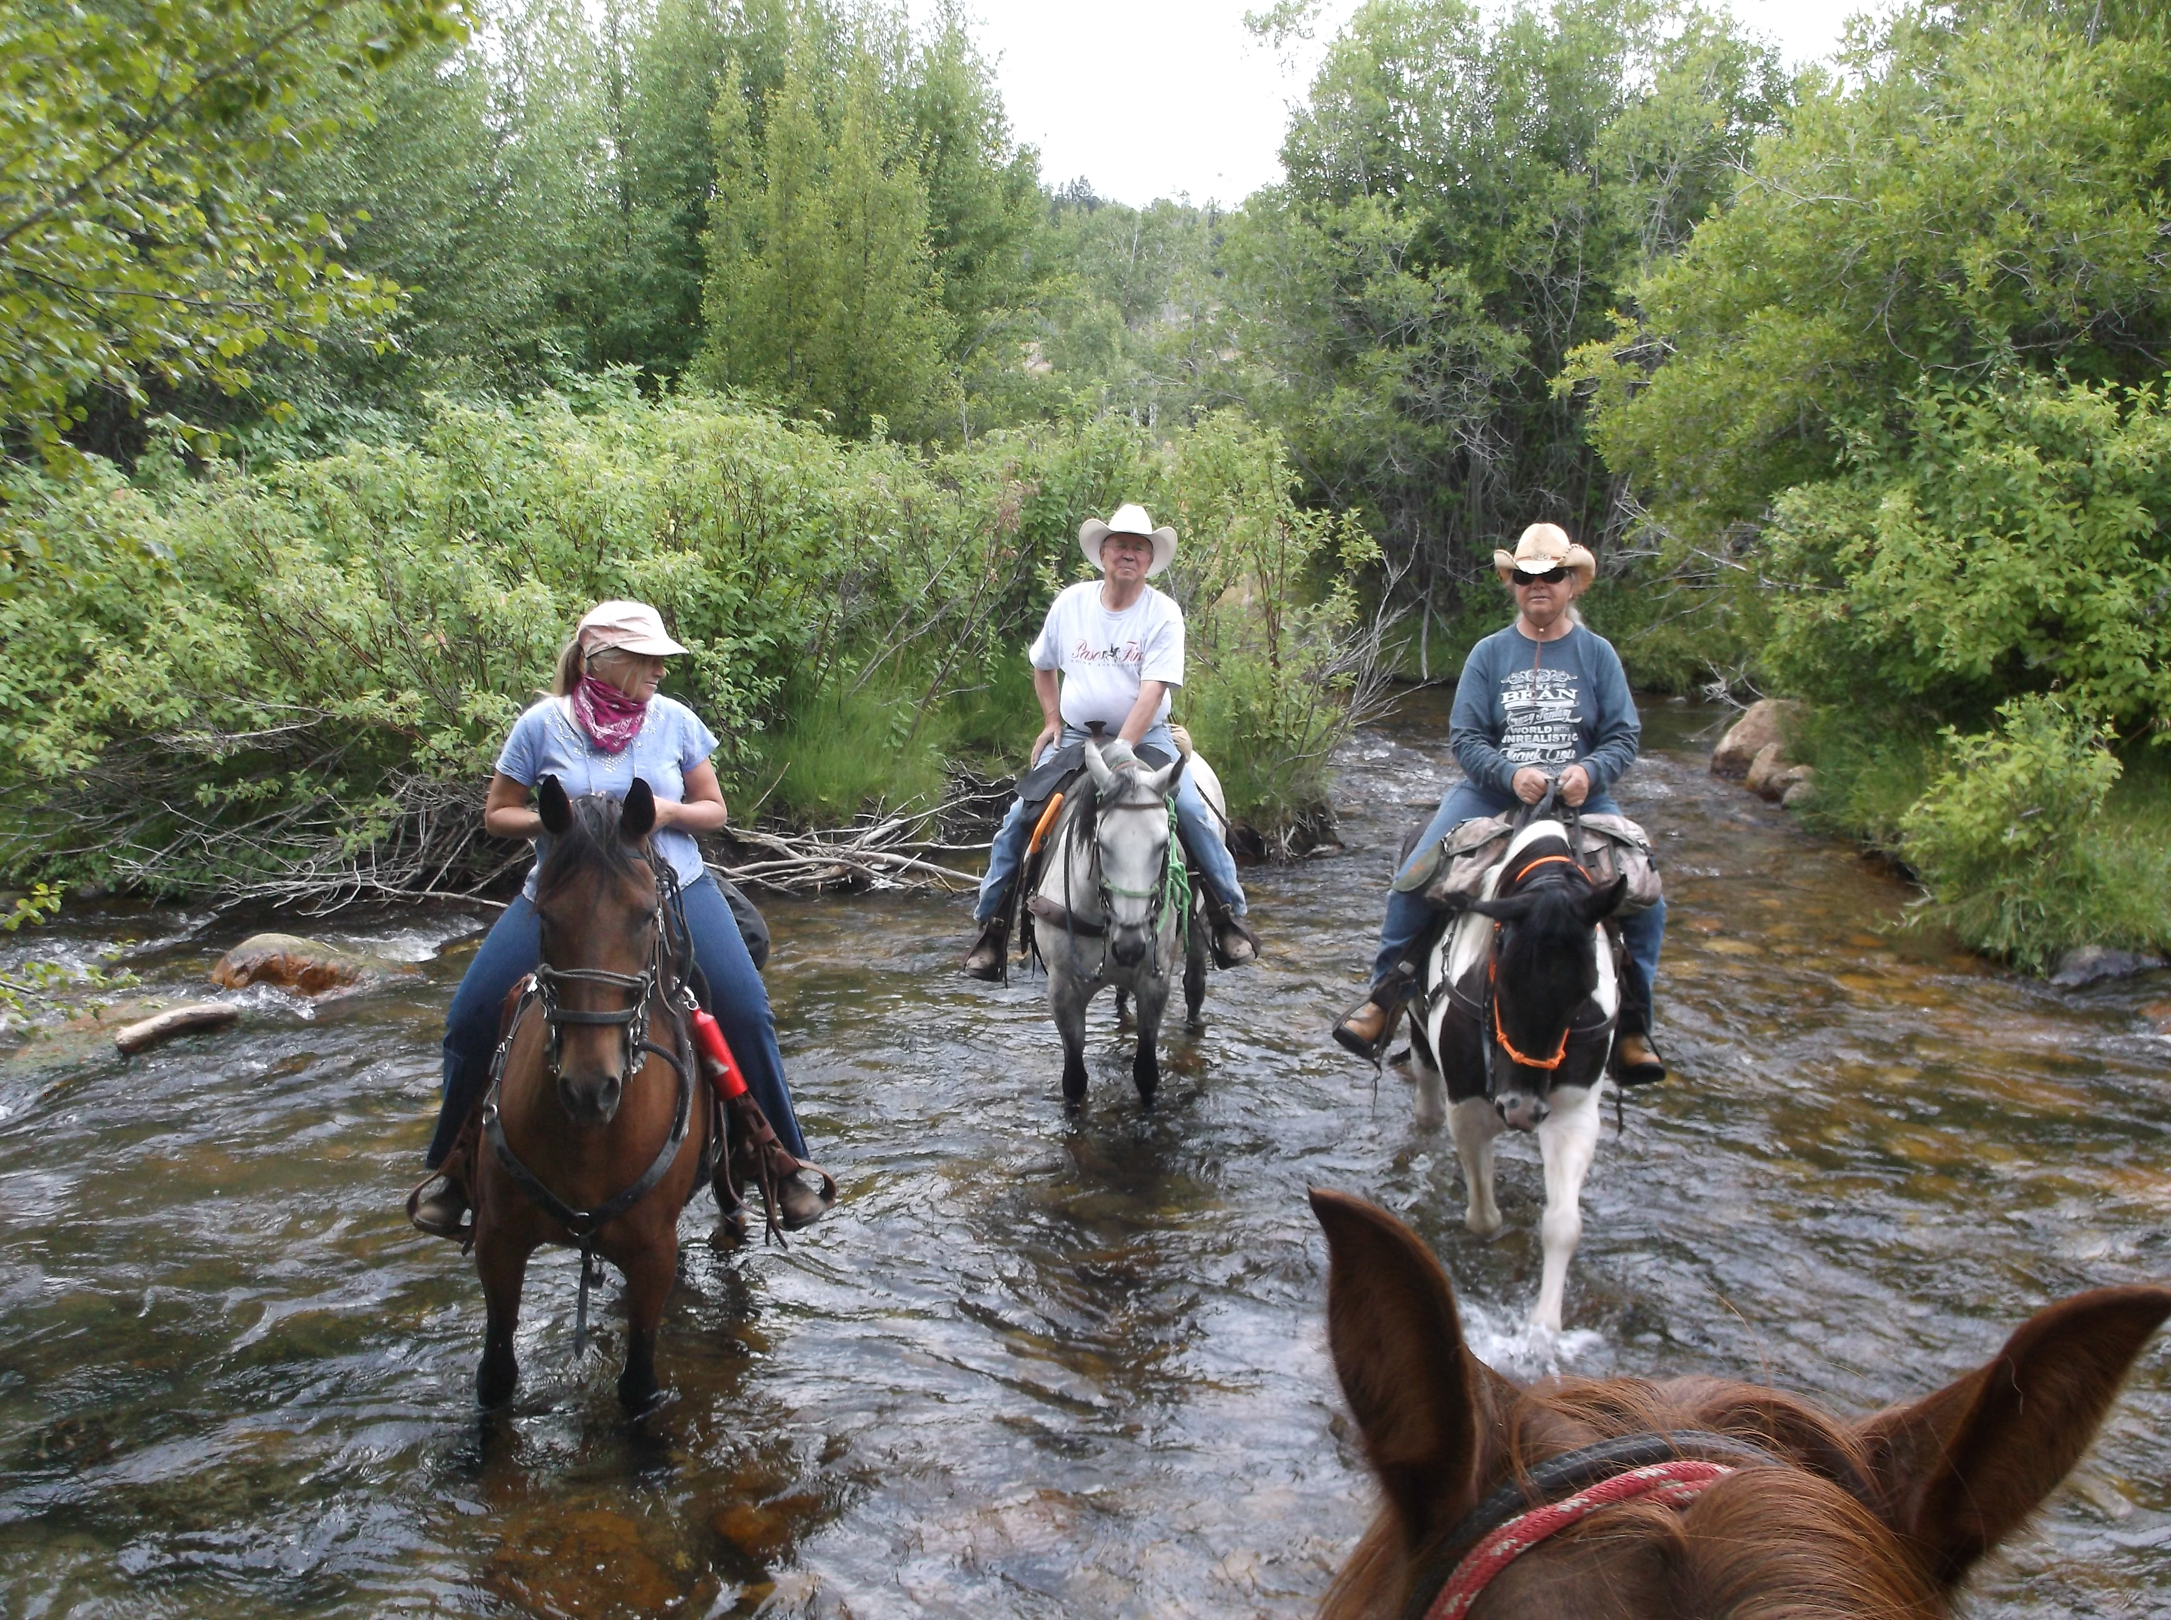
~ Additional optional fees: $20 for Senior test fee; $30 stall fee per night.
Trail Horse Test Master Judge
Christy Taylor
Event held at C & M Farm
1352 W. Syphon Road
Pocatello, Idaho

Submit entry forms to:
Judi Bradbury
111 Bertie Lord Lane
Conner, MT 59827

Trail Horse Test & Clinic

July 13 & 14, 2024
THT description and criteria are available at PFHA.org under the Recreational Rider tab.
- Program highlights the pleasure of riding a trail horse in a non-competitive environment.
- Test at either the Junior, Senior or both levels simultaneously.
- Additional info: Judi Bradbury at wbrad444@gmail.com

